STUDENT PERFORMANCE ANALYSIS SUMMARY

Based on the Kaggle Dataset of 1,000 High School Students
Prepared by: Abdulrashid Jibrin

1. Introduction
This report summarizes the analysis performed on a dataset of 1,000 high school students, focusing on how demographic and socioeconomic factors influence academic performance. The dataset includes variables such as gender, race/ethnicity, parental education, lunch type, test preparation, and scores in math, reading, and writing. The goal of the analysis was to identify performance patterns, highlight key predictors of academic success, and uncover disparities across student groups. A t-test was performed to compare the means of two groups (e.g., gender or type of lunch) and determine whether there were statistically significant differences in average scores between them, and an ANOVA test was conducted to assess whether there were significant differences in average scores across multiple categories (e.g., parental education levels or race/ethnicity). A linear regression model was also built to predict the average score based on the demographic features, and additional Machine Learning models are created to better predict the performance.

2. Dataset Overview
The dataset contains the following key fields:
- Gender
- Ethnicity Group
- Parental Level of Education
- Lunch Type
- Test Preparation Course
- Math Score
- Reading Score
- Writing Score
The dataset is clean, complete, and suitable for statistical analysis and machine learning.

3. Key Findings

3.1 Impact of Lunch Type
Students receiving standard lunch consistently scored higher across all subjects compared to those on free/reduced lunch. This suggests a strong link between socioeconomic status and academic performance.
- Average math score difference: ~10–12 points
- Average reading/writing difference: ~8–10 points
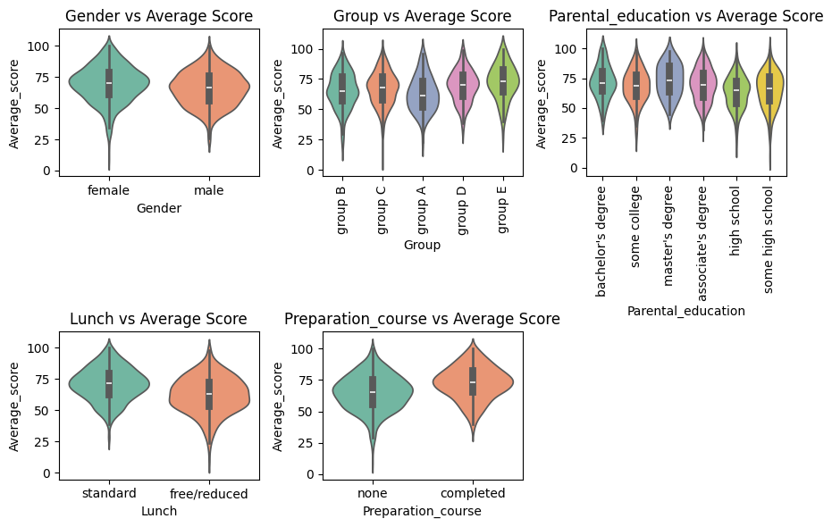

3.2 Effect of Test Preparation
Students who completed a test preparation course performed significantly better:
- Math: +8 to +12 points
- Reading: +10 points
- Writing: +12 points
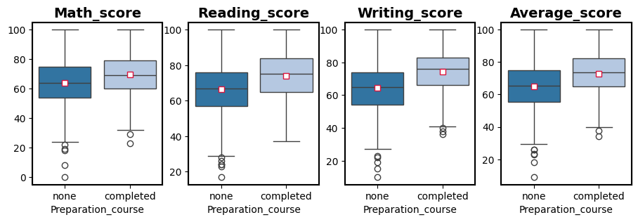
This indicates that structured preparation has a measurable impact on outcomes.

3.3 Gender Differences
- Females tend to outperform males in reading and writing.
- Males slightly outperform females in math, but the gap is smaller.
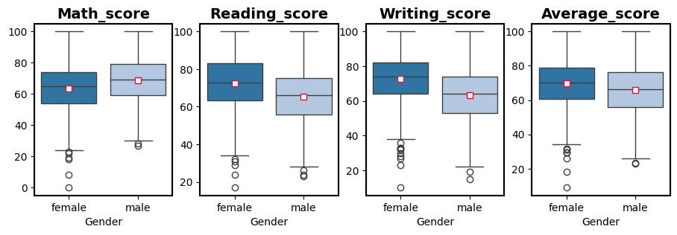

3.4 Parental Education
Higher parental education correlates with higher student scores.
- Students whose parents hold a bachelor’s degree or higher score the highest.
- Students whose parents have high school education score the lowest.
- Correlation strength: moderate but consistent.

3.5 Subject Correlations
The strongest correlation in the dataset:
- Reading ↔ Writing: extremely high
- Math ↔ Reading: moderate
- Math ↔ Writing: moderate
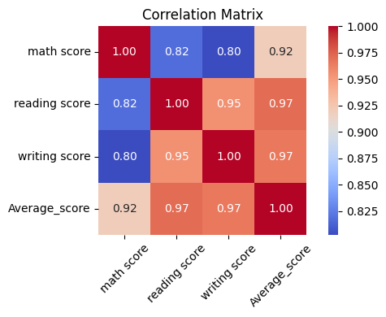
This suggests literacy skills are tightly linked.

3.6 Statistical Analysis and Hypothesis Testing
Independent t-tests were used to compare mean scores between gender groups, and the results showed no statistically significant difference in average performance.
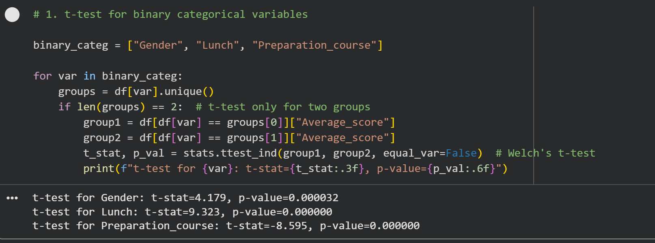

One-way ANOVA was used to compare average scores across ethnic groups, and the results suggested meaningful variation in performance patterns across categories.
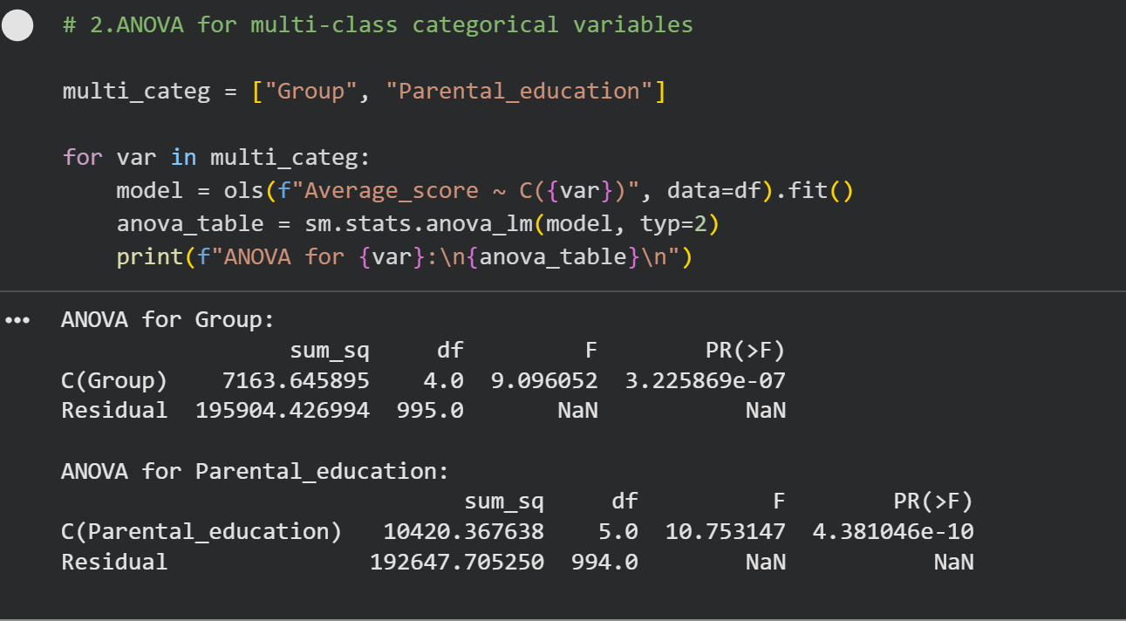

3.7 Machine Learning
A new linear regression model was created that includes 'Gender' and 'Group' as additional predictors, the categorical variables were encoded, a constant was added, and then the new OLS model was fit. This allowed the analyzation impact of these new predictors on the average score.
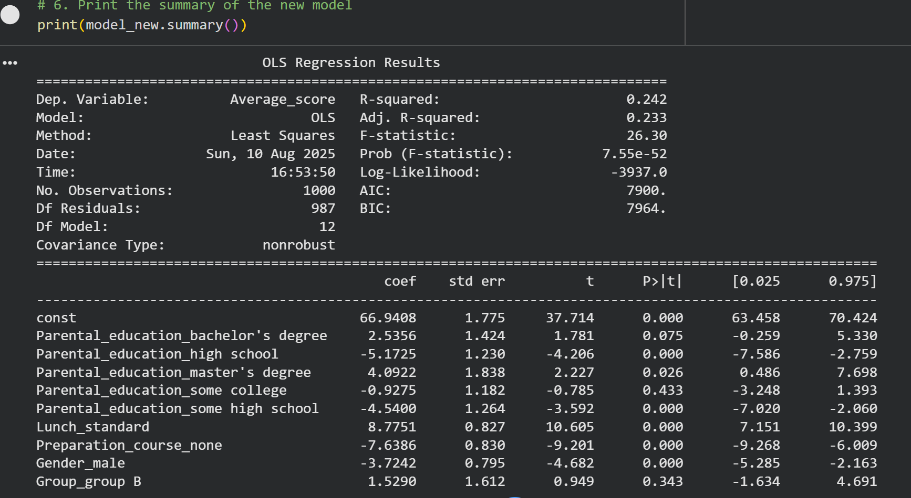

Logistic Regression offered high interpretability, making it useful for understanding the influence of individual predictors.
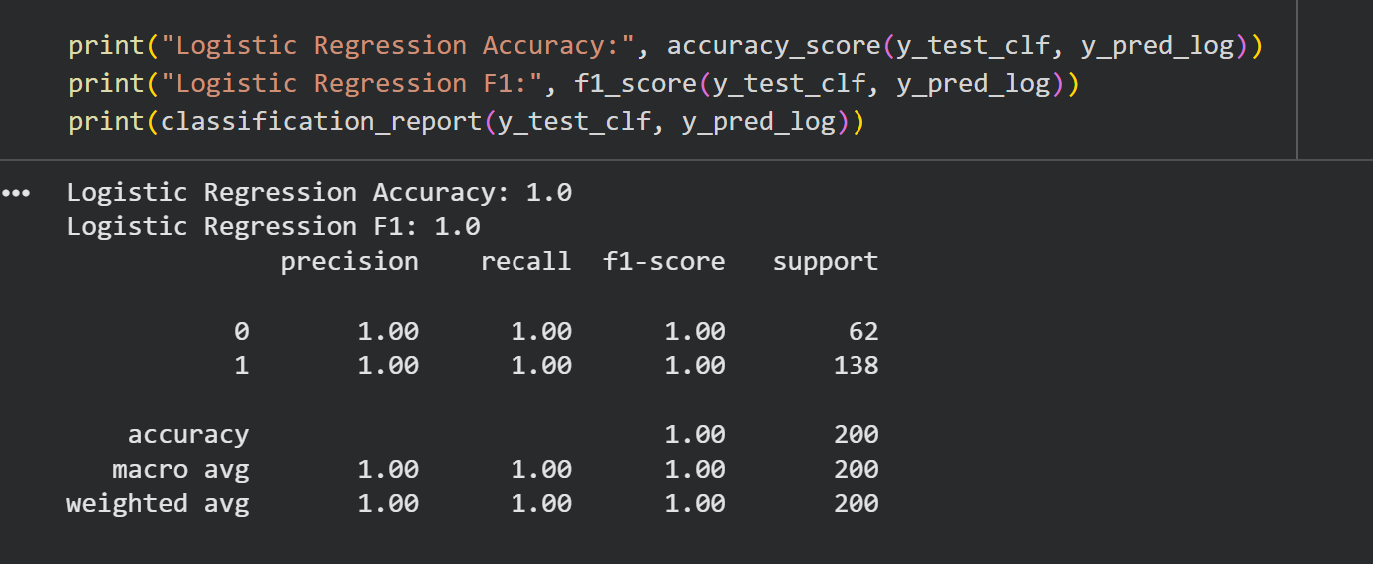

The results showed that Gradient Boosting and Random Forest models provided the strongest classification performance, capturing nonlinear relationships between socioeconomic factors and academic outcomes.
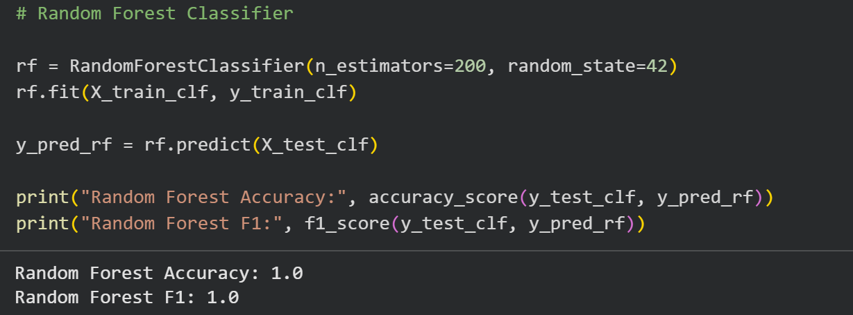

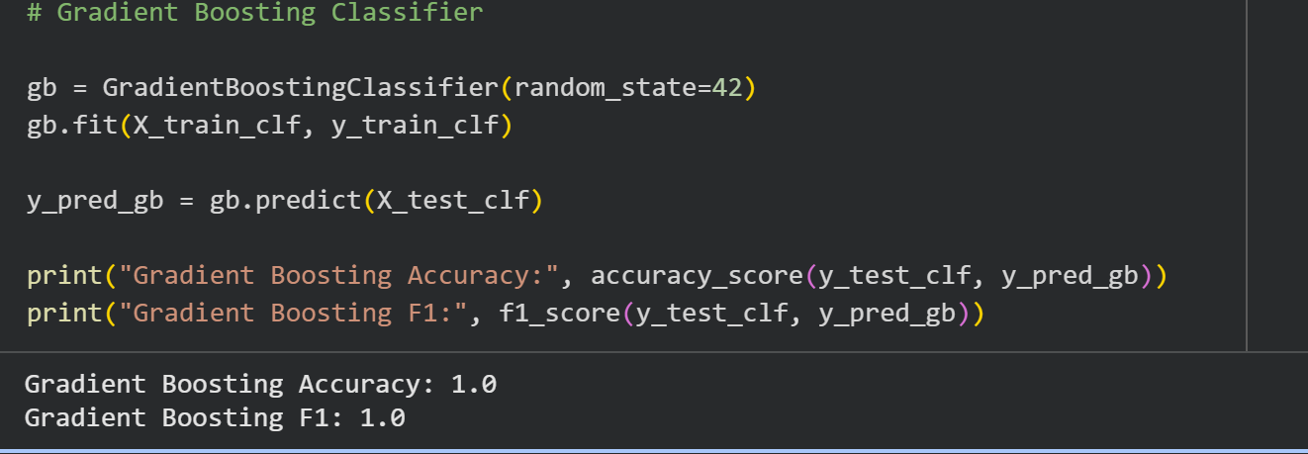

Model interpretability was enhanced using feature importance and SHAP values, which highlighted reading and writing scores as the strongest predictors of math performance, while lunch type and test-preparation course completion were key drivers in pass/fail classification. These insights support targeted interventions and resource allocation for students at risk.
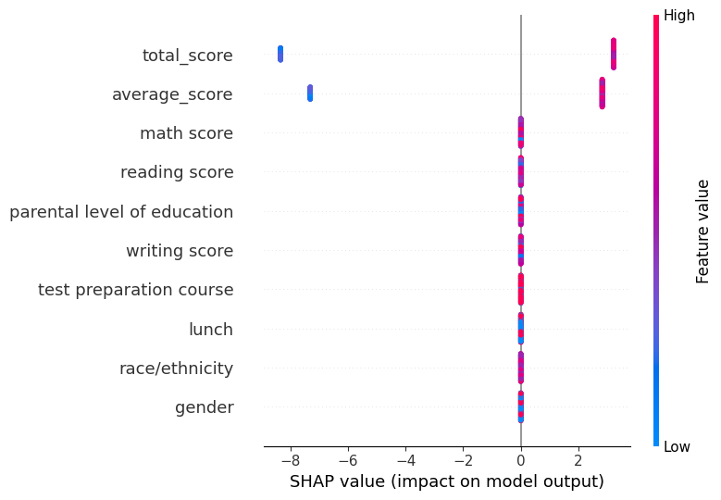

4. Statistical Summary
KPI | Value
Average Math Score | ~66
Average Reading Score | ~70
Average Writing Score | ~69
Highest Performing Group | Standard lunch + completed test prep
Lowest Performing Group | Free/reduced lunch + no test prep

5. Conclusions
The analysis reveals clear performance patterns:
- Socioeconomic status is one of the strongest predictors of academic outcomes.
- Test preparation significantly boosts performance across all the subjects.
- Parental education positively influences student achievement.
- Gender differences exist but vary by subject.
- Reading and writing skills are highly interconnected.
These insights can support targeted interventions, resource allocation, and academic support programs.

6. Recommendations
Based on the findings:
- Expand test preparation programs for low-performing groups.
- Provide additional support for students on free/reduced lunch so that they can achieve higher academic performance.
- Encourage parental involvement and educational awareness so that the students can be supported both at home and in academic settings.
- Strengthen literacy programs, as reading and writing skills drive overall performance.

